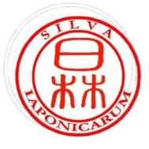
Review Form | Silva Iaponicarum

Reviewer code:
Title of the paper:

Date of the review:

Part I. Questionnaire.
Please answer “yes” or “no” to questions 1–4 and indicate the answer which applies in question 5.

- Is the paper a new and original contribution?
- Does the title of the paper reflect its content accurately?
- Is the structure of the paper clear and logical?
- Are the references relevant, sufficient and up-to-date?
- Should the paper be published?
- Yes, in its current form.
- Yes, with minor adjustments.
- Yes, but only with major changes/updates.
- No, it should not be published.

Part II. Comments/feedback (optional).

